Pizza Sales SQLQueries

A: KPI’s

1.Total Revenue
select round (SUM(total_price),2) as Revenue from pizza_sales;
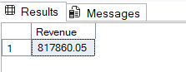

AVG Order value

select ROUND( SUM(total_price) / count(DISTINCT order_id),3) as avg_order_value
from pizza_sales;
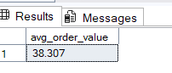

-- Avg pizzas per order
SELECT cast (cast(sum(quantity) as decimal(10,2)) /cast(count(distinct order_id)
as decimal(10,2)) as decimal(10,2))as avg_pizzas_per_order from pizza_sales;
( CAST is used for print output in decimal )
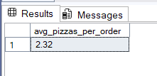

-------------------------Charts Requirement----------------------------------------
1: Daily Trend for total orders: find out how many sales per day
select DATENAME(DW,order_date) as order_date,count(DISTINCT order_id) as total_orders
from pizza_sales
group by DATENAME(DW,order_date);
(--DW:day of week)
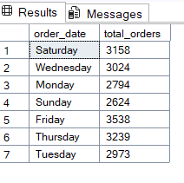
2: Monthly Trend for total Orders
select DATENAME(MONTH,order_date) as Month_Name,count(DISTINCT order_id) as Total_orders
from pizza_sales
group by DATENAME(MONTH,order_date)
order by Total_orders desc ;
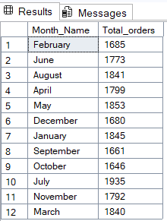

3: Total % of sales per category
select distinct pizza_category,sum(total_price) * 100/(select sum(total_price) from pizza_sales)as total_Sales
from pizza_sales
group by pizza_category;
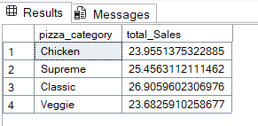
4: % of sales by pizza size
select DISTINCT pizza_size,ROUND(sum(total_price)*100/(select sum(total_price) from pizza_sales),3) as total_sales_per_Size
from pizza_sales
group by pizza_size;

